20 SDU points awarded upon successful completion
w.e.f. 15 Sept 2018 - Course fee will be revised, and SDF funding migrated to NETT fee.
COURSE OVERVIEW |  |  |  |  |  |  |  |  | COURSE OBJECTIVES
The “Managing Work-At-Heights” course integrates the existing WAH courses into a holistic programme to provide a broad overview of working at heights. The courses for supervisors, assessors and managers are integrated to provide trainees a better understanding and appreciation of each role’s system. |  |  |  |  |  |  |  |  | - Identify, explain and apply the relevant Workplace Safety and Health (WSH) Legislations / Approved Code of Practice / Singapore Standards applicable to Work-at-Heights (WAH)  - Identify and explain the Roles & Responsibilities of stakeholders, competent and responsible persons  - Identify hazards, evaluate the risk and implement control measures for WAH activities  - Review the necessary fall prevention / protection control measures for safe execution of WAH activities  - Establish, evaluate, review and implement a Fall Prevention Plan  - Establish and implement a system for an effective monitoring and control of WAH risks  - Demonstrate competency in donning, checking and correcting of Individual Fall Protection Equipment and First-line Response in an emergency
COURSE DETAILS |  |  |  | PASS CRITERIA
Course Duration  - Theory – 9.5 hours  - Practical – 6 hours  - Assessment – 5 hours |  |  |  | - Theory – 70%  - Practical – 100%
ENTRY REQUIREMENTS
- WSQ ESS Workplace Literacy and Numeracy (WPLN) Level 4, or equivalent.
Course Fees |  | : | S$299.60/- per participant (NETT)
Medium |  | : | English
Course Time |  | : | Day 1 : 9.00 AM – 6.00 PM  Day 2 : 9.00 AM – 5.30 PM  Day 3 : 9.00 AM – 3.00 PM |  |  |  | Venue |  |  |  | : |  | 1 Soon Lee Street, #04-05/06/07, Pioneer Centre, Singapore 627605
(Fill in dates as per schedule on website)

- PARTICULARS OF COMPANY AND CONTACT PERSON
(This portion MUST be completed for company sponsored course, leave blank if otherwise)

Company Name | :
Mailing Address | :
Name | : |  | Tel | :
Designation | : |  | Fax | :
Email | : |  | Mobile | :

- PARTICULARS OF TRAINEE

Full Name | : |  |  |  |  | NRIC/FIN | :
Home Address | : |  |  |  |  | Home Tel | :
Email | : |  |  |  |  | Mobile | :
Date of Birth | : |  | Qualification | : |  | Nationality | :

Please send form with a copy of your NRIC/FIN to training@avanta.com.sg or fax to 6295 6683.

Declaration
I declare that the particulars given by me in this registration and the attached sheets are true to the best of my knowledge and belief, and acknowledged and accepted the terms and conditions stated overleaf.

 | Signature of Applicant |  | Company Stamp |  | Date
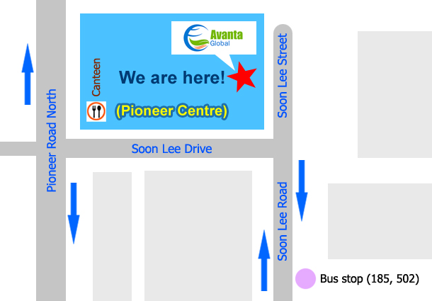

COURSE REGISTRATION AND PROCEDURES

Below refund policies are made available to trainees via Avanta’s website, online registration forms and hard/soft copy registration forms.

- Course registration shall be applied at least 3 days in advance. Registration is based on a first-come-first-served basis. To confirm the registration, payment of the course fees must be made before the commencement date. Avanta Global Pte Ltd (Avanta) reserves the right to decline a trainee from attending the class at its sole discretion.
- Certificate/card shall be issued within 1 month from the course completion date. For WDA courses, SOA shall be ready within 3 months from the assessment completion date as per WDA’s T&Cs. No certificate/card will be issued unless full payment is received by Avanta before the course ends. An email notification will be sent once the certificate/card is ready for collection. Uncollected certificate/card within 3 months from the date of email notification will be destroyed. An administrative charge apply to re-printing of replacement certificate/card at $20/-. (Police report is required for lost certificate/card case.)
- Trainee is reminded to attend class punctually. Full course fees will still be imposed if the trainee does not attend the class without prior notice.
- Notice of replacement or withdrawal must be made in writing to Avanta subjected to the following:
  - No *administrative charge if notice of replacement reaches Avanta at least 3 working days before the course commencement date. Replacement of trainee is allowed only once.
  - 90% refund of course fees if notice of withdrawal reaches Avanta at least 2 weeks before the course commencement date.
  - 75% refund of course fees if notice of withdrawal reaches Avanta less than 2 weeks but more than 3 working days before the course commencement date.
  - No refund of course fees if notice of withdrawal reaches Avanta 2 working days or less before the course commencement date.

All requests are subjected to the discretion and approval of Avanta.
- Reschedule or change of course is allowed once only and is subjected to the availability of the course. An *administrative charge is applicable if the request is made 2 working days or less before the course commencement date.
- Avanta reserves the rights to cancel the course or change the course dates. Refund of full course fees is applicable if the class is cancelled by Avanta.

*Administrative charge: 10% of the course fees or S$30/- (whichever is higher)

By submitting this form, you hereby agree to Avanta’s privacy policies. A copy of the privacy statement is available on our website at http://avanta.com.sg/privacy-statement/.

FOR OFFICIAL USE ONLY

Supporting Documents | : | Copy of NRIC/FIN Copy of highest qualification
Payment Collected | : | No  Yes Date: Mode: Cash / Cheque ____ _____
Course Confirmation | : | No  Yes Date: Mode: Email / Self Collect
Verified by / Date | :

