w.e.f. 15 Sept 2018 - Course fee will be revised, and SDF funding migrated to NETT fee.

Target Audience | Course Outline
- Individuals who are to undertake the role of a supervisor in the marine industry.  - Workplace Safety and Health (Shipbuilding and Ship-Repairing) Regulations 2008 Reg. 6 (8) stipulates that: “It shall be the duty of every person not to oversee or supervise any work (including any process) in the shipyard or on board a ship in a harbour unless he has received adequate safety and health training to ensure that the work that he oversees or supervises can be carried out safely.” | - An Overview of Workplace Safety and Health Legislation  - General Safety in Shipyard  - Confined Space Entry  - Hot Works  - Electrical Hazards  - Surface Treatment  - Material Handling  - Working At Height  - Risk Assessment  - Occupational Health  - Accident Investigation and Safety Inspection
Required Skills & Knowledge
Workplace literacy and numeracy Level 4 under Employability Skills System (ESS) or equivalent

Course Fee |  |  | : | S$256.80/- per participant (NETT)
Duration |  |  | : | 32 hours (including 3 hours of assessment)
Time |  |  | : | Day 1 to 3 : 8.30 AM – 6.30 PM  Day 4 : 9.00 AM – 3.00 PM (Exam : 12.00 PM – 3.00 PM)
Pass Criteria |  |  | : | Attendance 75% / Assessment 65%
Medium |  |  | : | English
Venue |  |  | : | 1 Soon Lee Street, #04-05/06/07 Pioneer Centre, Singapore 627605
(Fill in dates as per schedule on website)

- PARTICULARS OF COMPANY AND CONTACT PERSON
(This portion MUST be completed for company sponsored course, leave blank if otherwise)

Company Name | :
Mailing Address | :
Name | : |  | Tel | :
Designation | : |  | Fax | :
Email | : |  | Mobile | :

- PARTICULARS OF TRAINEE

Company Name | :
Full Name | : |  |  |  |  | NRIC/FIN | :
Home Address | : |  |  |  |  | Home Tel | :
Email | : |  |  |  |  | Mobile | :
Date of Birth | : |  | Qualification | : |  | Nationality | :

Please send form with a copy of your NRIC/FIN to training@avanta.com.sg or fax to 62956683.

Declaration
I declare that the particulars given by me in this registration and the attached sheets are true to the best of my knowledge and belief, and acknowledged and accepted the terms and conditions stated overleaf.

Name / Signature |  | Company Stamp |  | Date

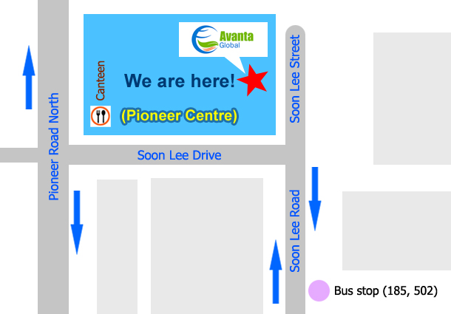

COURSE REGISTRATION AND PROCEDURES

Below refund policies are made available to trainees via Avanta’s website, online registration forms and hard/soft copy registration forms.

- Course registration shall be applied at least 3 days in advance. Registration is based on a first-come-first-served basis. To confirm the registration, payment of the course fees must be made before the commencement date. Avanta Global Pte Ltd (Avanta) reserves the right to decline a trainee from attending the class at its sole discretion.
- Certificate/card shall be issued within 1 month from the course completion date. For WDA courses, SOA shall be ready within 3 months from the assessment completion date as per WDA’s T&Cs. No certificate/card will be issued unless full payment is received by Avanta before the course ends. An email notification will be sent once the certificate/card is ready for collection. Uncollected certificate/card within 3 months from the date of email notification will be destroyed. An administrative charge apply to re-printing of replacement certificate/card at $20/-. (Police report is required for lost certificate/card case.)
- Trainee is reminded to attend class punctually. Full course fees will still be imposed if the trainee does not attend the class without prior notice.
- Notice of replacement or withdrawal must be made in writing to Avanta subjected to the following:
  - No *administrative charge if notice of replacement reaches Avanta at least 3 working days before the course commencement date. Replacement of trainee is allowed only once.
  - 90% refund of course fees if notice of withdrawal reaches Avanta at least 2 weeks before the course commencement date.
  - 75% refund of course fees if notice of withdrawal reaches Avanta less than 2 weeks but more than 3 working days before the course commencement date.
  - No refund of course fees if notice of withdrawal reaches Avanta 2 working days or less before the course commencement date.

All requests are subjected to the discretion and approval of Avanta.
- Reschedule or change of course is allowed once only and is subjected to the availability of the course. An *administrative charge is applicable if the request is made 2 working days or less before the course commencement date.
- Avanta reserves the rights to cancel the course or change the course dates. Refund of full course fees is applicable if the class is cancelled by Avanta.

*Administrative charge: 10% of the course fees or S$30/- (whichever is higher)

By submitting this form, you hereby agree to Avanta’s privacy policies. A copy of the privacy statement is available on our website at http://avanta.com.sg/privacy-statement/.

FOR OFFICIAL USE ONLY

Supporting Documents | : | Copy of NRIC/FIN Copy of highest qualification
Payment Collected | : | No  Yes Date: Mode: Cash / Cheque ____ _____
Course Confirmation | : | No  Yes Date: Mode: Email / Self Collect
Verified by / Date | :

